**COMSATS University Islamabad (CUI)**

Project Proposal  
(SCOPE DOCUMENT)

for

**Spatial Neglect**  
Version 1.0

***By***

**Danish Ali CUI/FA18-BCS-017/ISB**

**Malaika Atiq CUI/FA18-BCS-040/ISB**

***Supervisor*Sir Khurram Iqbal**

*Bachelor of Science in Computer Science (2018-2022)*

**Table of Contents**

Table of Contents

Abstract 1

1. Introduction 1

2. Problem Statement 3

3. Problem Solution/Objectives of the Proposed System 3

4. Related System Analysis/Literature Review 3

5. Advantages/Benefits of Proposed System 4

6. Scope 4

7. Modules 4

7.1 Module 1: Account Manager 4

7.2 Module 2: Neglect Detector with Whiteboard 5

7.3 Module 3: Neglect Rehabilitator 5

7.4 Module 4: Report Generator and Milestone 5

7.5 Module 5: Patient and appointment Logging 6

7.6 Module 6: Reviews and Feedback 6

7.7 Module 7: Payments 6

8. System Limitations/Constraints 6

9. Software Process Methodology 6

10. Data Gathering Approach 7

11. Tools and Technologies 7

12. Project Stakeholders and Roles 8

13. Module based Work Division 8

14. WBS and Gantt Chart 9

15. Mockups 9

16. References 10

17. Plagiarism Report 11

**Project Category: (**Select all the major domains of proposed project**)**

□ **B-**Web Application/Web Application based Information System □ **C-**Problem Solving and Artificial Intelligence □ **D-**Simulation and Modeling □ **H-**Image Processing

# Abstract

Neglect App shall be Web Application for Spatial Neglect Patient treatment. Spatial Neglect Patients are unable to perceive stimuli on one side of the body or environment and hence may take care of only one side of the body or environment and neglect the other. Neglect App will be designed to provide doctors a platform for their patients’ treatment. Neglect app will predict the Neglect disability based upon exercise performed by a patient such as copying a picture and determine whether disability is found or not based upon copying accuracy.

Then Rehabilitation Plan starts providing patient with many exercises and Performance and improvements of patient’s condition is measured accordingly depending upon exercise results. Reports are generated analyzing the Patient performance and more future exercises, trends are suggestions. Milestone setter on completion on every Appointment provide points to patient based upon performance, summarizing where rehabilitation plan reached. Doctor can view the reports of patients, comparison between different Patient’s improvement. Doctors will provide feedbacks and reviews about their experience with app and will be able to report problems.

# Introduction

Neglect App will be an application designed for doctors to assess and rehabilitate patients with a disorder known as **Spatial Neglect**. Spatial neglect is a neuropsychological condition in which after damage to one hemisphere of the brain, a person loses his/her ability to perceive stimuli on one side of the body or environment. Among many other causes, it may be caused due to traumatic brain injury (TBI). A person with spatial neglect may take care of only one side of his body while he neglects the other, for example shaving only one side of the face. Though there is no standard cure for this disorder yet, but doctors use some assessment and rehabilitation exercises with the patients that might help them.

So, through this app doctors will be able to make their patients perform assessment exercises for them, while our algorithms determine if the patient has left or right neglect. Several rehabilitation exercises will be available. Doctors will also be able to keep a log of their patients, while the app stores each of the patient’s progress. Reports about patient performance will be generated along with milestone setting for next appointment. Doctors will be able to provide feedback and reviews.

# Problem Statement

**Proposed system will provide necessary exercises to doctors for rehabilitation and detection of spatial neglect in patients. Our system will make it easier for doctors to visualize the performance of patients in appointments through graphs. It will help the doctor, better understand where a patient stands and if there’s any improvement or not. The accuracy of this system will help the doctor to make better decisions in the process of rehabilitation.**

# Problem Solution/Objectives of the Proposed System

Main objectives and goals are as follows.

* Neglect Application shall provide a utility to Doctor to register patients and detect the Neglect disability in patients using neglect detector.
* Neglect Application will provide a rehabilitation plan consisting visual search exercises performed by patients will be measured accordingly.
* Reports will be generated based on result of exercises performed in appointments.
* Performance of Patients will be compared, and comparison will be visualized through graph and Statistical table.
* Future Milestones for appointments will also be updated after completion of each appointment.
* Application will make easier for doctors to keep track of patient improvements.
* Application will provide doctor a facility of reporting problems and providing feedback, reviews.

# Related System Analysis/Literature Review

Table 1: Related System Analysis with Targeted Neglect Solution.

|  |  |  |
| --- | --- | --- |
| **Application Name** | **Weakness** | **Proposed Project Solution** |
| * Visual Attention Therapy Lite | * Provides no detection for the disorder. * Rehabilitation only provided for left   neglect.   * Image copying exercises not available. * No Future predictions and trend setting involved on basis of reports. | * Our application will detect both Left and Right Neglect. * Rehabilitation tasks can be useful for both left and right neglect patients. * Image copying activities will be available also. * Future predictions and trend setting will be involved on basis of reports generated from patient performance. |

# Advantages/Benefits of Proposed System

* This Application will provide a platform for neglect detection and rehabilitation.
* Doctors will be able to keep track of patients and their improvement.
* Milestones trends setting will predict the necessary improvements to be reach, helping doctors in decision making.
* Patients will do exercises on every appointment day helping them to rehabilitate from neglect issue.

# Scope

The proposed system is a web application designed for doctors to assess and rehabilitate patients suffering from Spatial neglect. The doctor will be able to keep a log of his patients and schedule appointments, where in each appointment, the patient will perform the required exercises. The doctor will be able to generate reports and visualize them to understand the severity of the disorder of his/her patient and make better decision regarding rehabilitation plan.

Proposed Application will be doctor driven. Future milestones values can vary in accuracy.

Neglect detector and rehabilitator cannot replace the doctor, it can only help doctor for better decision-making regarding treatment in future.

Figure1: Context Diagram for Neglect App

# Modules

## Module 1: Account Manager

Account manager will be consisted of user account related tasks. Varieties of options will be provided to doctors for signing up for using Application services.

* Doctors will be able to Sign up and then login.
* Doctors can manage their profile information.
* Doctors will add Patients and update and delete patients record.
* Guardians will be able to Sign up and then login
* Guardian can manage their profile
* Admin will be able to login.
* Admin will be able to delete or block doctor.
* Admin will be able to verify payments.
* Admin will be able to add images in training set

## Module 2: Neglect Detector with Whiteboard

Neglect detector will be an entry point to the way of patient treatment. Neglect detector will determine whether a neglect issue exists in a patient or not.

* Provides patient with an image to copy.
* Whiteboard will be provided with marker to copy the given image on whiteboard.
* Timer will start when exercise begins.
* After finishing exercise our CNN classifier will determine while copying patient neglected left side or right side of an image.
* Neglect will be detected.

## Module 3: Neglect Rehabilitator

After successful detection of neglect, Patient will be provided with Rehabilitation exercises to measure accuracy and in this way, patient will be able to help himself in rehabilitating from neglect through performing exercises in different appointments. Rehabilitation program will consist of a series of rounds and each round will be consisted of exercises.

* Patients will be need to scratch circles in an image through marker provided.
* After finishing exercise our trained Model will generate report giving information about how many circles he found and correctly scratched.
* Report will also tell how many circles he/she missed to scratch hence accuracy will be measured.
* After finishing a round graph will be shown representing performance exercises wise.

## Module 4: Report Generator and Milestone

For better understanding of patient recovery and improvement in exercise performance, graphs will be generated that will clearly express where rehabilitation plan of patient is reached and in comparison, with other patients where he stands according to improvements?

* Doctor will be able to generate report of patients based on his performance in exercises during appointments
* Comparison between recovery of patient with other patients will be represented in form of graph through ML models with respect to performance in each appointment.
* Statistical data about recovery during each appointment will be also shown in table form.
* Doctor will be able to create and save his observations about reports for future use.
* Guardians will be able to view reports of their related patients.
* They can get better idea of improvement in patient situation.

Based on performance of exercises performed during previous appointments, new milestone points will be awarded to reach in next appointment. Milestone point will be basically a performance measure that will tell doctor about where rehabilitation program reached and what is next goal of improvement for patient.

* Milestone point for next appointment will be generated for current patient.
* Doctor will be able to create and save text note about milestones for future use.

## Module 5: Patient and appointment Logging

Doctors need to maintain log of patients so appointments related work will be done. It will make easier for doctor to view schedule appointments and manage appointments accordingly

Guardian can add patient

* Guardians will be able to add patient record and manage it.
* Guardians will be able to send request to doctor for patient rehabilitation.
* Guardians can also send query to doctor.
* Doctors will be able to accept or reject guardian request for rehabilitation.
* Allow doctors to keep log of his patients and schedule appointments for them.
* Allow doctors to start or finish appointments.
* Allow doctors to reset appointments if needed
* Doctors will be able to see brief record of patients.

## Module 6: Reviews and Feedback

It will be platform where Doctors, Guardians can post his queries or report a problem or provided feedback about app. Admin will reply to posted queries or feedback

* Doctor will be able to post a query or feedback.
* Doctor will be able to review his query if he finds any mistake.
* Guardians will be able to post a review also.
* Admin will be replying to queries posted.

## Module 7: Payments

Doctor will be able to pay charges for using the application services through credit card.

* Doctor will be able to pay charges through credit card.
* Doctor will be able to pay charges through Providing bank account information also.
* Admin will verify the payment information.

# System Limitations/Constraints

* The Neglect Detector and rehabilitator cannot replace itself with doctors, it helps doctor for better decision-making regarding treatment.
* The copying accuracy measured can vary so doctors need to analyze and make decision accordingly.
* Future trends generated from reports can vary in accuracy.
* This application will be Doctor driven.
* Doctor needs to have knowledge about graphs.
* Guardians needs to understand the instructions related to detection exercise performed for better detection of patient neglect.

# Software Process Methodology

We will be using incremental process model to Develop our application as it is simple and easy to implement and we can develop our application in parts and test parts at that time, avoiding future problems. We will develop our application in form of increments like firstly developing account managing and then neglect detection and rehabilitation and on every increment development we will test it also to avoid any future bug.

# Data Gathering Approach

Neglect Detection and Rehabilitation requires a lot of information about Spatial Neglect Disease features. We gathered data through Google Search about Spatial Neglect, interviewing psychologist we know and learned more about the behavior of Spatial Neglect patients and the exercises that might help them get better. We also brainstormed about exercises we can arrange for patient neglect detection and rehabilitation. We joined a network for spatial neglect which is online platform for spatial neglect analysis and gather information about patient behavior.

# Tools and Technologies

Table 2: Tools and Technologies for the Neglect App.

|  |  |  |
| --- | --- | --- |
| **Tools** | **Version** | **Rationale** |
| MS Visual Studio Code | 2019 | IDE |
| MongoDB | 4.3.0 | NoSQL DB |
| Adobe Photoshop | 22.3.1 | Design Work |
| MS Visio | 2019 | Design Work |
| MS Word | 2019 | Documentation |
| MS Power Point | 2019 | Presentation |
| Balsamiq Wireframes | 4.0.48 | Mockups Creation |
| Postman | 8.5.1 | API Testing |
| Google Collaborator | - | ML model training |
| **Technology** | **Version** | **Rationale** |
| Python | 3.8.3 | Programming language |
| Flask | 2.0.3 | Python web framework |
| Node.js | 14.6. 1 | Backend Programming |
| CSS | 3 | Web Development |
| JavaScript | 1.8.5 | Web Development |
| HTML | 5 | Web Development |
| React.js | 17.0.2 / 22 March 2021 | JavaScript Frontend Library |
| Express | 4.17.1 | Node Framework |
| TensorFlow.js | 3.0 | Python library for ML and DL |
| Open CV | 4.5.5 | Computer vision Library |
| JavaScript | ES6 | Programming Language |
| AOS | 2.0.0 | Scroll Animations Library |
| Material UI | V5.4.4 | React Component Library |
| Cloudinary | V3 | API for media management |

# Project Stakeholders and Roles

Table 3: Project Stakeholders for the Neglect App.

|  |  |
| --- | --- |
| **Project Sponsor** | COMSATS University Islamabad |
| **Stakeholder** | * Student names: Malaika Atiq FA18-BCS-040, Danish Ali FA18-BCS-017 * Project Supervisor Name: Mr. Khurram Iqbal * Final Year Project Committee: Evaluation of project |

# Module based Work Division

Table 4: Team Member Work Division for Neglect App.

|  |  |  |
| --- | --- | --- |
| **Student Name** | **Student Registration Number** | **Responsibility/ Modules** |
| Malaika Atiq  Danish Ali | FA18-BCS-040  FA18-BCS-017 | (These are shared collective modules for both of us)  Module 2, Module 3, Module 4  (Machine learning tasks) |
| Malaika Atiq | FA18-BCS040 | Module 5 & Module 7  (Handle payments and database tasks for patient logging) |
| Danish Ali | FA18-BCS-017 | Module 1 & Module 6  (Db tasks for reviews and feedbacks and handling accounts.) |

# WBS and Gantt Chart

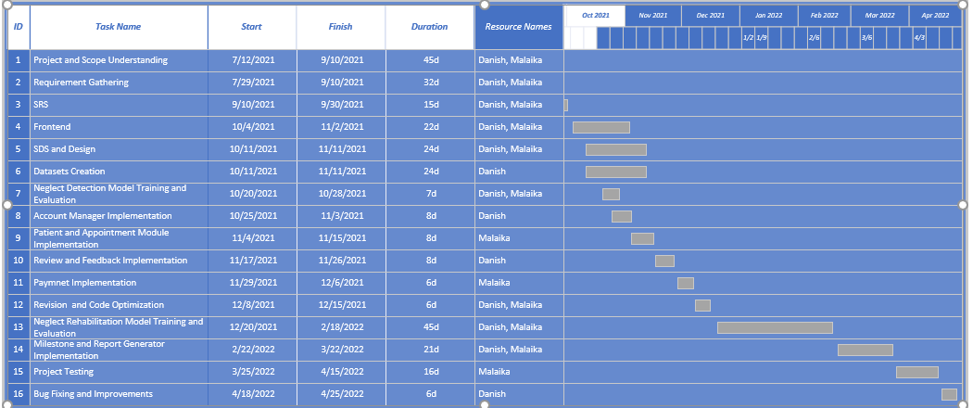

Figure 2: Gantt Chart of Neglect App

# Mockups

**Figure 3: Design Mockup for Doctor Dashboard for Patient Panel**

**Figure 4: Design mockup for neglect rehabilitator**

**Figure 5: Design Mockup for Exercise Report**

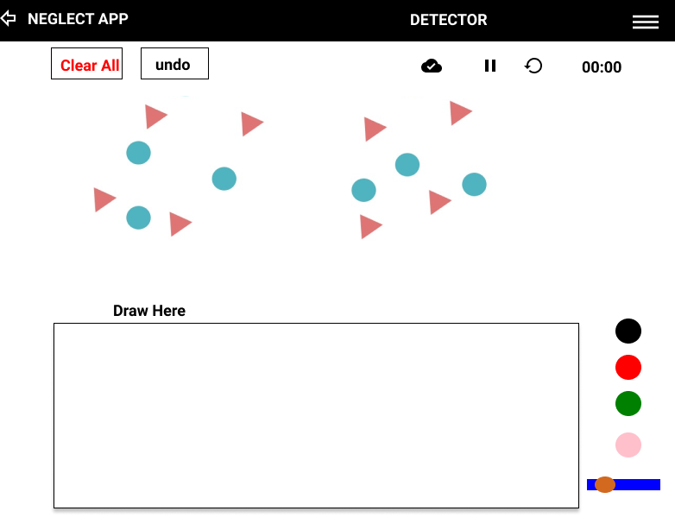

**Figure 6: Design mockup for whiteboard neglect detector**

**Figure 6: Design mockup for whiteboard Report Generator**

# References

* Network for Spatial Neglect Community:

<https://kesslerfoundation.org/researchcenter/stroke/nsnapplication#:~:text=The%20Network%20for%20Spatial%20Neglect,various%20types%20of%20spatial%20neglect>.

* Network for Spatial Neglect Community:

<https://kesslerfoundation.org/researchcenter/stroke/nsnapplication#:~:text=The%20Network%20for%20Spatial%20Neglect,various%20types%20of%20spatial%20neglect>.

* Visual Attention Therapy Lite:

<https://play.google.com/store/apps/details?id=com.tactustherapy.vat.lite&hl=en&gl=US>

* Neglect Treatment: <https://tactustherapy.com/visual-scanning-treatment/>
* Spatial Neglect and aspects: <https://www.ncbi.nlm.nih.gov/pmc/articles/PMC6262901/>
* AI, NodeJS: <https://developer.ibm.com/technologies/artificial-intelligence/tutorials/an-introduction-to-ai-in-nodejs/>

# Plagiarism Report

